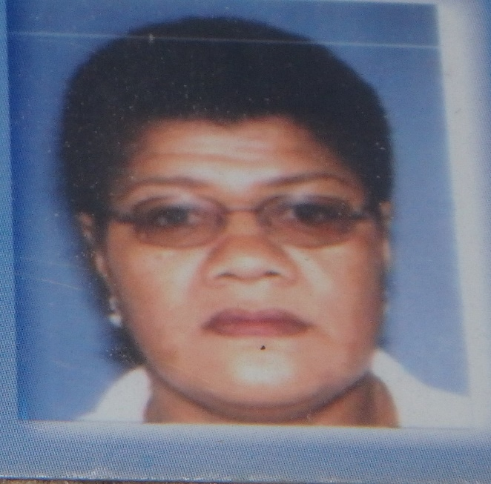

Name: Ms Lanieta Vakadewabuka
Profession: Local Consultant –Statistics/ Gender & Rural Development
Former Senior Statistician- Fiji Bureau of Statistics (Household Survey Unit) 30 years work experience in both economic and social statistics
Key Areas of Expertise: Statistical Survey Methodology, Data Collection, Data Analysis, Rural Development & Empowerment through information sharing and Consultation
Education- Bachelors of Arts Degree -(Sociology, Public Administration & Management)
Certificate in General Statistics- United Nations Statistical Institute for Asia & Pacific (UNSIAP), Tokyo, Japan
Distinction Certificate in Survey Methodology-United Nations Statistical Institute for Asia & Pacific (UNSIAP) Tokyo, Japan
Other Statistics technical training
Why am I involved in WIFN-Fiji?- I am passionate about working with Women and Children in Rural and Peri Urban communities to improve their living standards and alleviate poverty.
During my years of work with the Fiji Bureau of Statistics and the Ministry of Rural Development, I have been able to identify and work in communities and issues that affect and have an impact on their daily lives.
WIFN is an opportunity to further address, serve the interest and improve the lives of Women and Children in the Peri Urban and Rural Communities.

